UNIT-1

Difference between Harvard and Princeton Architecture
Harvard Architecture | Princeton Architecture
┌─────────────────────────────┐ | ┌─────────────────────────────┐
Separate memory is used for program and data. | Same memory is used for program and data.
└─────────────────────────────┘ | └─────────────────────────────┘
Separate buses are used for instruction and data. | Common bus is used for instruction and data.
Program memory and data memory are independent. | Program and data share the same memory space.
Instruction and data can be accessed simultaneously. | Instruction and data are accessed through the same bus.
Generally faster. | Generally slower due to shared bus.
Hardware is more complex. | Hardware is simpler.
More hardware/cost is generally required. | Less hardware/cost is generally required.
Commonly used in microcontrollers and DSPs. | Commonly used in general-purpose computer system.
Harvard Architecture  - In Harvard architecture, program memory (instruction memory) and data memory are separate. They have separate buses, so instruction and data can be accessed at the same time.  Princeton Architecture  -Princeton architecture is also called Von Neumann architecture. Here, program and data are stored in the same memory and use a common bus. | 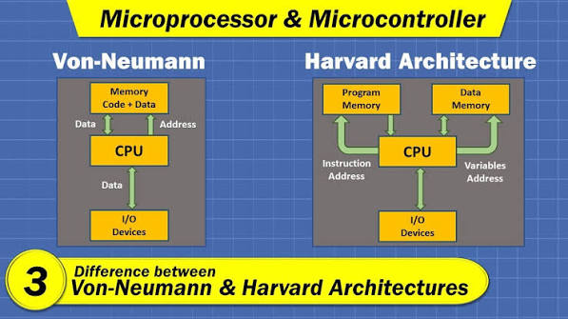
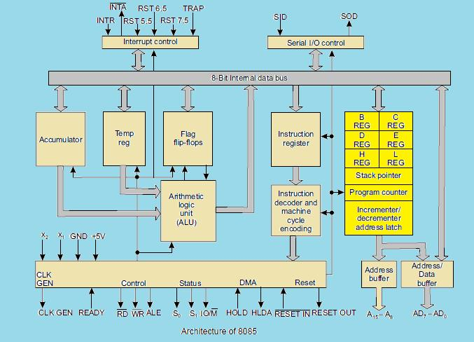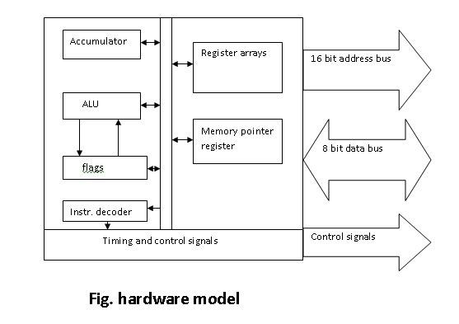
Accumulator (A) | Stores data/results temporarily

ALU | Does addition, subtraction, AND, OR, etc.

Flag Register | Shows the result condition, e.g. zero, carry

General Registers | B, C, D, E, H, L store temporary data

Program Counter (PC) | Holds the address of next instruction

Stack Pointer (SP) | Points to the top of stack

Instruction Register | Holds the current instruction

Instruction Decoder | Understands/decodes the instruction

Timing & Control Unit | Controls and synchronizes all operations

Address/Data Bus | Carries address and data between CPU, memory and I/O
Simple working:
Instruction → Decoder → Control Unit → ALU/Registers → Result
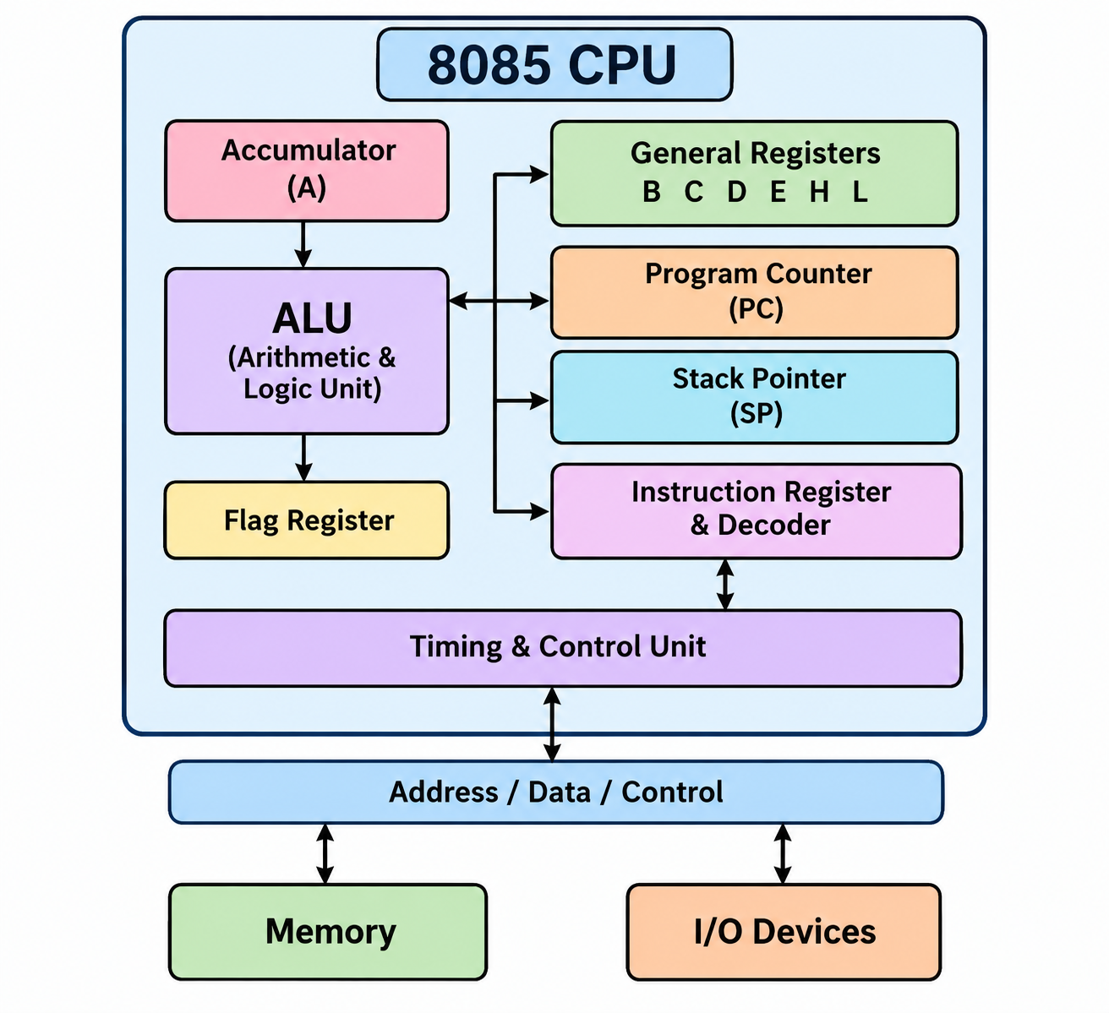PIN DIGRAM
Address Bus | A8–A15 | Memory का address बताता है

Address/Data Bus | AD0–AD7 | Address + Data दोनों

Control Signals | ALE, RD, WR | Operations को control करते हैं

Status Signals | S0, S1, IO/M | Processor की स्थिति बताते हैं

Interrupts | TRAP, RST 7.5, RST 6.5, RST 5.5, INTR, INTA | Interrupt handling

Power & Clock | VCC, VSS, X1, X2, CLK OUT | Power और clock
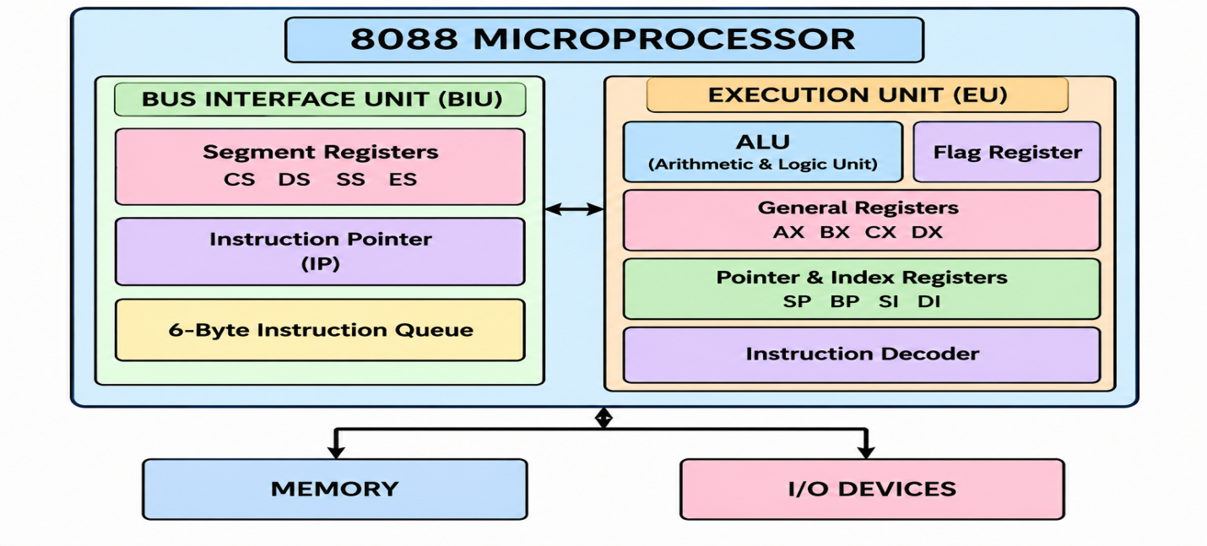
OOOoror

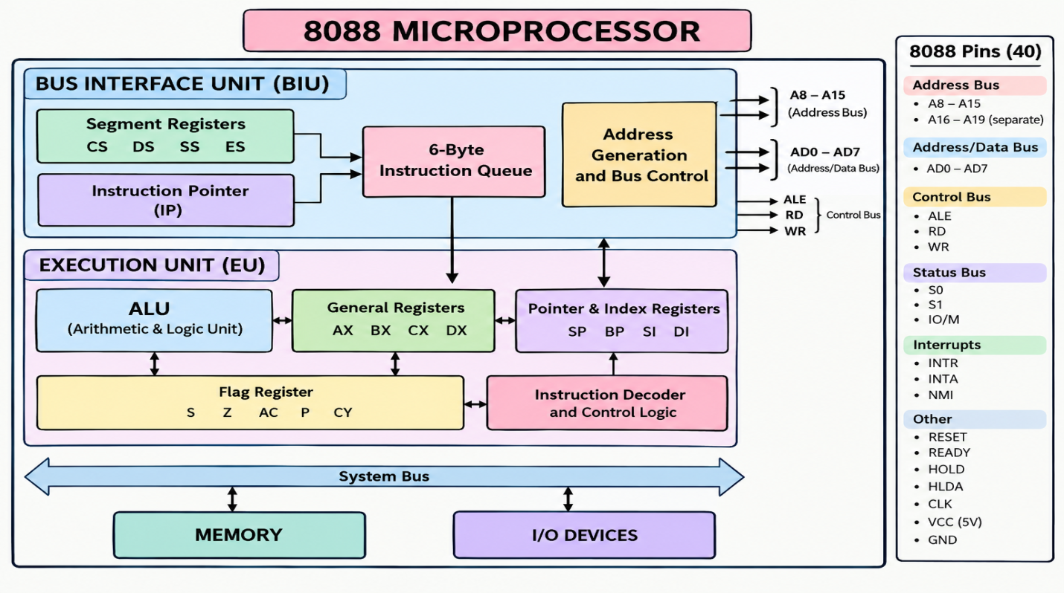

8088 Block Diagram – Short Notes
8088 Microprocessor → 2 Units

1. BIU – Bus Interface Unit
- Segment Registers: CS, DS, SS, ES
- IP: Next instruction ka address
- Instruction Queue: 4-byte
- Main work: Memory se instruction fetch karna

2. EU – Execution Unit
- ALU: Arithmetic & Logic operations
- General Registers: AX, BX, CX, DX
- Pointer & Index: SP, BP, SI, DI
- Flag Register: Result ki condition show karta hai
- Instruction Decoder: Instruction ko decode karta hai
- Main work: Instruction execute karna
8086 ↓ Memory Interfacing ↓ Address Decoding ↓ I/O Interfacing ↓ I/O Port Address Decoding ↓ 8255 → I/O Ports ↓ 8254 → Timing ↓ DMA → Direct Data Transfer
UNIT -4
8086 has two operating modes: Minimum Mode, Maximum Mode

Minimum Mode
Single processor के लिए।,8086 खुद control signals देता है, MN/MX̅ = 1, USED IN simple system

Maximum Mode

Multiple processors , 8086 status signals देता है, 8288 Bus Controller control signals बनाता है।
MN/MX̅ = 0 , USE IN complex system

What is Memory Interface?
Memory Interface means connecting memory (RAM/ROM) with 8086. so that the microprocessor can read data from memory and write data into memory. memory is connected with 8086 using address bus, data bus and control signals. 8086 can access 1 MB memory

What is I/O?
I/O means Input/Output.
- Input → Data is given to the microprocessor.
- Output → Data is received from the microprocessor.
- Examples- Input devices: Keyboard , Output devices: Display ,Printer
I/O Interface is a connection between the microprocessor and I/O devices.
It helps the microprocessor to communicate with input and output devices.

What is an I/O Port?
An I/O Port is a location/address used by the microprocessor to communicate with an I/O device. I/O Port Address Decoding is the process of selecting the correct I/O device using its port address.
The address decoder checks the address given by 8086 and generates a chip select (CS) signal for the required I/O device. CS = Chip Select

UNIT–IV: MEMORY AND I/O INTERFACING

Topics
- Minimum and Maximum Mode Configuration of 8086
- Memory Interface with 8086
- Address Decoding
- Basic I/O Interface
- I/O Port Address Decoding
- 8255 Programmable Peripheral Interface
- 8254 Programmable Interval Timer
- Direct Memory Access (DMA)
- Basic DMA Operation
1. Minimum Mode and Maximum Mode of 8086
8086 can work in two modes:

1. Minimum Mode
- Used when only one processor is present in the system.
- 8086 itself generates all control signals.
- Simple and less expensive system.

2. Maximum Mode
- Used when more than one processor or coprocessor is present.
- An external 8288 Bus Controller is used.
- Suitable for complex systems.

Main Difference
Minimum Mode | Maximum Mode
Single processor system | Multiprocessor system
8086 generates control signals | 8288 generates control signals
Simple system | Complex system
MN/MX̅ = 1 | MN/MX̅ = 0

Easy Trick:
MIN = One processor
MAX = More processors

2. Memory Interface with 8086

What is Memory Interface?
Memory interface means connecting memory devices (RAM/ROM) with the 8086 microprocessor so that 8086 can read and write data.
8086 has:
- 20 address lines → A0 to A19
- 16 data lines → D0 to D15
- Address bus = 20-bit
- Data bus = 16-bit

Memory Capacity
8086 can access:
2²⁰ = 1 MB memory
So,
8086 → 1 MB memory address space

Memory Banks in 8086
8086 has a 16-bit data bus, but memory is divided into two banks:

1. Even Bank
- Stores even addresses
- Connected to D0–D7
- Called Low Bank

2. Odd Bank
- Stores odd addresses
- Connected to D8–D15
- Called High Bank

Important Signals
A0 and BHE̅ are used to select memory banks.
A0 | BHE̅ | Selected
0 | 0 | Both banks
0 | 1 | Even/Low bank
1 | 0 | Odd/High bank
1 | 1 | No bank

Easy Remember:
A0 → Low bank
BHE̅ → High bank

3. Address Decoding

Definition
Address decoding is the process of selecting a particular memory or I/O device using its address.
8086 sends an address through the address bus.
A decoder checks this address and selects the required device.

Example:
Suppose we have:
- RAM
- ROM
- I/O device
When 8086 sends an address, the decoder decides which device should respond.

Simple Block Diagram
8086
|
Address Bus
|
+-----------+
| Decoder |
+-----------+
/ | \
/ | \
RAM ROM I/O

Why Address Decoding is Needed?
- To select the correct memory location.
- To avoid two devices responding at the same time.
- To generate Chip Select (CS) signal.

4. Basic I/O Interface

What is I/O?
I/O means:
Input / Output
Input devices give data to the microprocessor.
Examples:
- Keyboard
- Sensor
- Switch
Output devices receive data from the microprocessor.
Examples:
- LED
- Display
- Printer

I/O Interface
I/O interface is the connection between:
Microprocessor ↔ I/O Device
It helps in proper transfer of data.
8086
|
I/O Interface
|
I/O Device

5. I/O Port

Definition
An I/O port is a location through which the microprocessor communicates with an I/O device.
Each port has a unique port address.
Example:
8086 → Port Address → I/O Device

Types of Ports
- Input Port
- Output Port
- Bidirectional Port

Input Port
Data moves:
Device → Microprocessor

Output Port
Data moves:
Microprocessor → Device

Bidirectional Port
Data can move in both directions.

6. I/O Port Address Decoding

Definition
I/O port address decoding is the process of selecting the required I/O device using its port address.
A decoder receives the address and produces the Chip Select (CS) signal.
8086
|
Address Bus
|
Decoder
|
+-----+-----+
| |
Port 1 Port 2

Main Purpose
- Select correct I/O device.
- Avoid unwanted device selection.

7. 8255 Programmable Peripheral Interface

Full Form

8255 = Programmable Peripheral Interface (PPI)
8255 is an I/O interface device used to connect peripheral devices with the microprocessor.

Important Point
8255 has 24 I/O pins.
These are divided into:
- Port A → 8 bits
- Port B → 8 bits
- Port C → 8 bits
Therefore:
8 + 8 + 8 = 24 I/O lines
8255 Ports

Port A
- 8-bit port
- PA0–PA7

Port B
- 8-bit port
- PB0–PB7

Port C
- 8-bit port
- PC0–PC7
Port C can also be divided into:
- Upper Port C → PC4–PC7
- Lower Port C → PC0–PC3

8255 Block Diagram
8086
|
+----------------+
| 8255 |
| |
| Port A | → PA0-PA7
| |
| Port B | → PB0-PB7
| |
| Port C | → PC0-PC7
| |
| Control Logic |
+----------------+

8. Modes of 8255
8255 has three operating modes:

Mode 0 – Simple I/O
- Basic input/output mode.
- No handshaking.
- Port works as simple input or output.

Mode 1 – Strobed I/O
- Uses handshaking signals.
- Used when data transfer needs control signals.

Mode 2 – Bidirectional I/O
- Data can move in both directions.
- Available mainly for Port A.
- Uses handshaking signals.

Easy Trick:
Mode 0 → Simple
Mode 1 → Handshake
Mode 2 → Bidirectional

9. 8254 Programmable Interval Timer

Full Form
8254 = Programmable Interval Timer
It is used for generating:
- Time delays
- Timing signals
- Square waves
- Counting events

Important Features
8254 contains 3 independent counters:
- Counter 0
- Counter 1
- Counter 2
Each counter is:
16-bit
So:
8254
|
+-- Counter 0
|
+-- Counter 1
|
+-- Counter 2
Each counter has:
- CLK → Clock input
- GATE → Control input
- OUT → Output

10. Uses of 8254
8254 can be used for:

1. Time Delay

Used to generate a required delay.

2. Event Counting
Counts external events.

3. Square Wave Generation
Generates square wave signals.

4. Frequency Generation
Can generate required frequencies.

11. Direct Memory Access (DMA)

Full Form
DMA = Direct Memory Access

Definition
DMA is a method in which an I/O device transfers data directly to/from memory without continuous involvement of the CPU.
Normally:
I/O Device → CPU → Memory
With DMA:
I/O Device ↔ Memory
↑
DMA
So CPU does not have to handle every byte of data.

12. Why DMA is Needed?
DMA is useful when large amounts of data have to be transferred quickly.
Examples:
- Hard disk
- Disk drive
- High-speed data acquisition
- Network devices

Advantages
- Faster data transfer
- Reduces CPU workload
- Useful for block data transfer

13. Basic DMA Operation
DMA operation can be understood in simple steps.

Step 1
I/O device sends a DMA request to the DMA controller.

Step 2
DMA controller requests the system bus from the CPU.

Step 3
CPU gives control of the bus to DMA controller.

Step 4
DMA controller transfers data:
Memory ↔ I/O device

Step 5
After transfer is completed, DMA controller releases the bus.

Simple Diagram
CPU
|
System Bus
|
DMA Controller
/ \
/ \
Memory I/O Device

14. DMA vs Normal Data Transfer
Normal Transfer | DMA Transfer
CPU is involved | CPU involvement is very low
Slower for large data | Faster
CPU transfers data | DMA controller transfers data
More CPU workload | Less CPU workload

DMA (Direct Memory Access)
DMA is a method of transferring data directly between Memory and I/O device without continuous involvement of the CPU.

1. DMA allows an I/O device to directly send or receive data from memory, so the CPU does not have to transfer every data item.

I/O Interface Using Peripheral Devices
I/O Interface (Input/Output Interface) is a hardware circuit that connects the microprocessor with peripheral devices.
Peripheral devices are external devices such as:
- Keyboard
- Printer
- Display
- ADC/DAC
- Sensors
- Motors

Simple diagram
┌─────────────────┐
│ MICROPROCESSOR │
│ 8086 │
└────────┬────────┘
│
System Bus
─────────┼─────────
│
┌────────▼────────┐
│ I/O INTERFACE │
└────────┬────────┘
│
┌────────────┼────────────┐
│ │ │
▼ ▼ ▼
Keyboard Printer Display

Why I/O Interface is required?
The microprocessor and peripheral devices have different:
- Speed
- Data format
- Operating requirements
Therefore, an I/O interface is used between them for proper communication.

2. I/O Interface Using Peripheral Devices

8255 PPI
Programmable Peripheral Interface
Used for connecting input/output devices with the microprocessor.

8254 PIT
Programmable Interval Timer
Used for generating accurate time delays and timing signals.

Basic connection
8086 MICROPROCESSOR
│
System Bus
│
┌─────────────┴─────────────┐
│ │
▼ ▼
┌───────────┐ ┌───────────┐
│ 8255 │ │ 8254 │
│ PPI │ │ TIMER │
└─────┬─────┘ └─────┬─────┘
│ │
┌────┼────┐ ┌─────┼─────┐
▼ ▼ ▼ ▼ ▼ ▼
Port A Port B Port C CLK GATE OUT
│ │ │
▼ ▼ ▼
Input Output Control
Device Device Device

3. 8255 PPI

Definition
8255 is a Programmable Peripheral Interface (PPI) used to interface peripheral devices with a microprocessor.
It has three 8-bit ports:
8255 PPI
┌───────────────┐
│ │
│ PORT A │ → 8-bit
│ PORT B │ → 8-bit
│ PORT C │ → 8-bit
│ │
│ Control Reg. │
└───────────────┘Ports
Port | Size | Use
Port A | 8-bit | Input / Output
Port B | 8-bit | Input / Output
Port C | 8-bit | Input / Output / Control

Port C can also be divided into:
- PC7–PC4 → upper 4 bits
- PC3–PC0 → lower 4 bits
Programmable Interval Timer – 8254
8254 is a Programmable Interval Timer (PIT) used with a microprocessor to generate accurate time delays, timing signals, and periodic signals.
Main Parts of 8254

① Data Bus Buffer
- It is an 8-bit bidirectional buffer.
- It connects the 8254 with the microprocessor data bus D0–D7.
- Data and control words are transferred through it.

② Read/Write Control Logic
It controls communication between the CPU and 8254.
Important signals:
- CS – Chip Select
- RD – Read
- WR – Write
- A0, A1 – Select counter/control register

③ Control Word Register
It stores the control word programmed by the CPU.
It decides:
- Which counter is selected
- Operating mode
- Binary/BCD operation
- Read/write operation
4. Three Counters
8254 contains three independent 16-bit counters:

5. Operating Modes of 8254
8254 has 6 modes:
MODE 0 → Interrupt
1 → One Shot
2 → Rate Generator
3 → Square Wave
4 → Software Strobe
5 → Hardware Strobe
Working of 8254-Suppose CPU wants a time delay.
If the counter is loaded with a particular count, it starts counting the incoming clock pulses.
When the required count is completed, the OUT pin changes its state according to the selected mode.
Thus, 8254 can generate the required delay or timing signal.
8254 is a Programmable Interval Timer used to generate accurate time delays and timing signals. It contains three independent 16-bit counters (Counter 0, Counter 1 and Counter 2). It has an 8-bit data bus buffer, read/write control logic and control word register. Each counter has CLK, GATE and OUT pins. 8254 has six operating modes: Mode 0 to Mode 5.

UNIT-1
• Explain Harvard Architecture and Princeton Architecture.
• Write the difference between Harvard and Princeton Architecture.
• Explain the basic features of 8085 microprocessor.
• Draw and explain the block diagram of 8085 microprocessor.
• Draw the pin diagram of 8085 and explain important pins.
• Write short note on 8088 microprocessor.
• Write the basic features of 8088 microprocessor.
• Compare 8085 and 8088 microprocessors.
• Explain Microprocessor-Based Personal Computer System.
Define a cycle of the processor?
Draw internal architecture of 8085 Microprocessor and explain function of each unit.
Compare Harvard and Princeton architecture of the processor. (d Write comparison between microprocessor 8085 and 8088.
Draw the flag register of 8085 microprocessor.
Explain the architecture of 8088 microprocessor.
Draw and discuss the read and write cycle timing diagram of 8086.
Give the difference between 8085 microprocessor and 8088 microprocessor in brief.
Which Intel Microprocessor was the first to address 1 M byte of memory (2018).
Draw the block diagram of 8088 microprocessor and explain the following: ES, CS, DS, SS, IP. SP, BP. SI, DI.

UNIT-2
• Differentiate between minimum mode and maximum mode.
• What is memory interfacing?
• What is address decoding?
• Explain memory address decoding.
• What is I/O interface?
• What is I/O port address decoding?
• Define I/O port.
• What is 8255 PPI?
• Write the features of 8255.
• What are the modes of 8255?
• What is 8254 Programmable Interval Timer?
• Write the features of 8254.
• What is DMA?
• Explain basic DMA operation.
• What is the need for DMA?
Interface two chips of 16K×8EPROM & two chips of 32K×8RAM with 8086 by selecting a suitable map.
Explain memory interfacing with 8086 microprocessor. What are the key feature & functionalities of the programmable peripheral interface (PPI) 8255?
Explain the Flag Register of 8085 Microprocessor with neat diagram.
Give the comparison between features of 8085 & 8088 microprocessor
Compare the Harvard & Princeton Architecture
Explain the Pin configuration of 8085 microprocessor
Explain the role of DMA in interfacing.
What are the key feature & functionalities of the programmable peripheral interface (PPI) 8255
Interface two chips of 16K×8EPROM & two chips of 32K×8RAM with 8086 by selecting a suitable map.
Explain I/O port addressing with example.

UNIT-2
Design an interface of two 4 K × 8 EPROMS and two 4 Kx 8 RAM chips with 8086 select suitable maps.
Draw and discuss typical minimum mode of 8086 system.
Explain 8254 functional block diagram.
Differentiate between minimum and maximum mode of 8086 processor.
Explain DMA controller as follows: (i) Architlecture (ii) Different operating Modes.
Draw suitable memory interface diagram with 8088 processor and calculate address range of each memory chip which are given below : 2 RAM chip of size 256*8 2 EPROM chip of size 256*8

